1. **Agenda**:
   1. Now let’s talk about the verification of the chain of trust.
2. This verification process happens when we open up any web page on **HTTPs**.
3. When you open web page, we see https sign near it and web server sends us **SSL Certificate (End-User Certificate)** along with all intermediate CA Certificates.
4. Then verification process starts on your machine with end-user certificate from leaf certificate towards the top certificate (Root one)  
   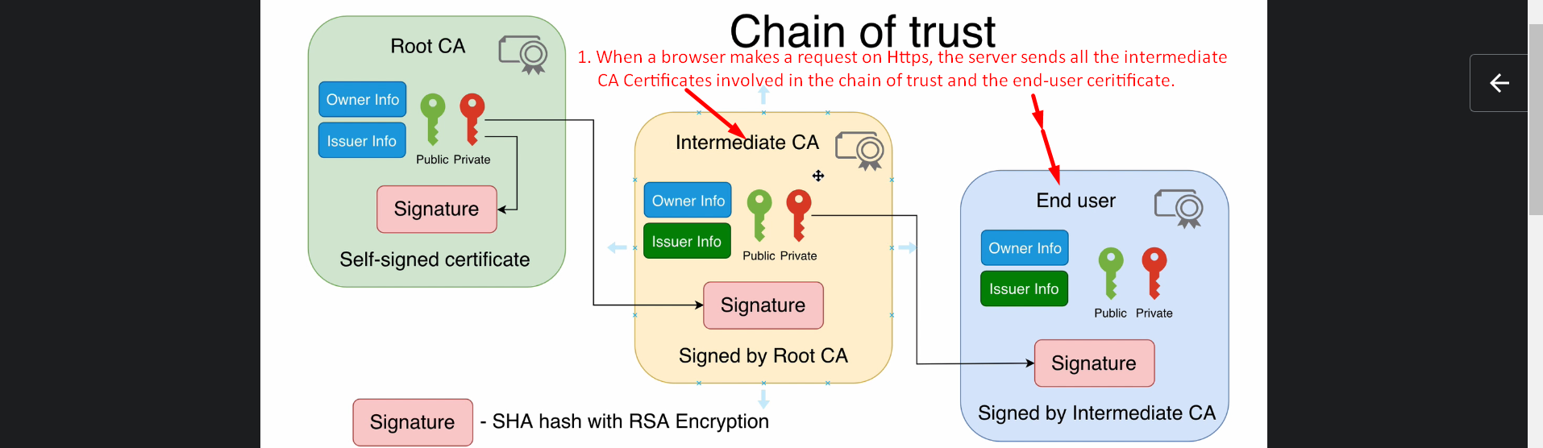
5. First our computer checks the following.   
   
6. Next step in verification 🡪   
     
     
   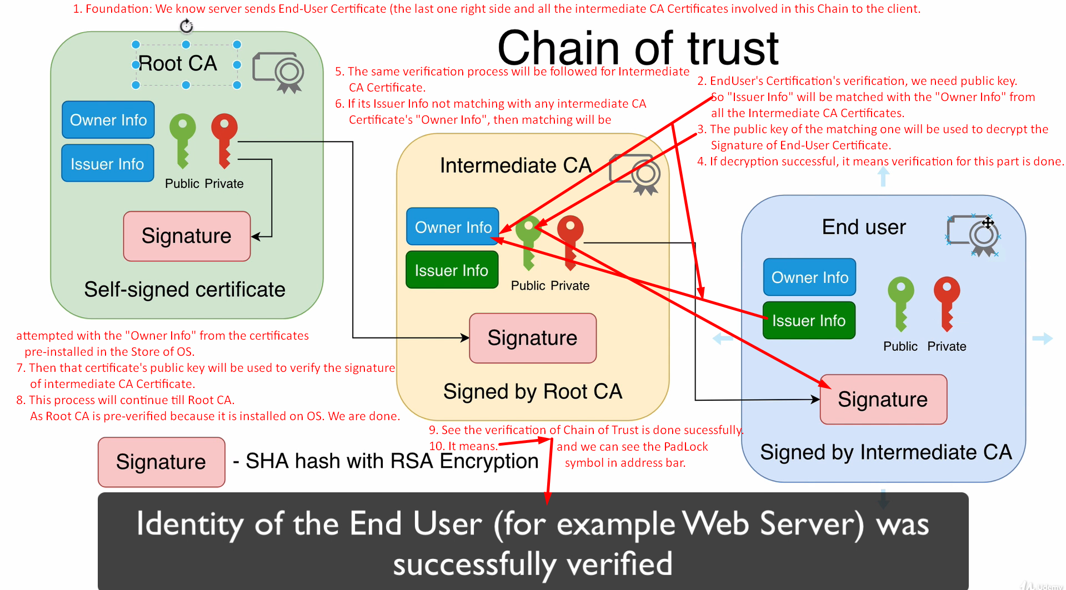
7. The following slides are just for information. You may skip.   
     
     
     
   
8.  
9. 
10. 
11.  